**Litomyšl jinak**

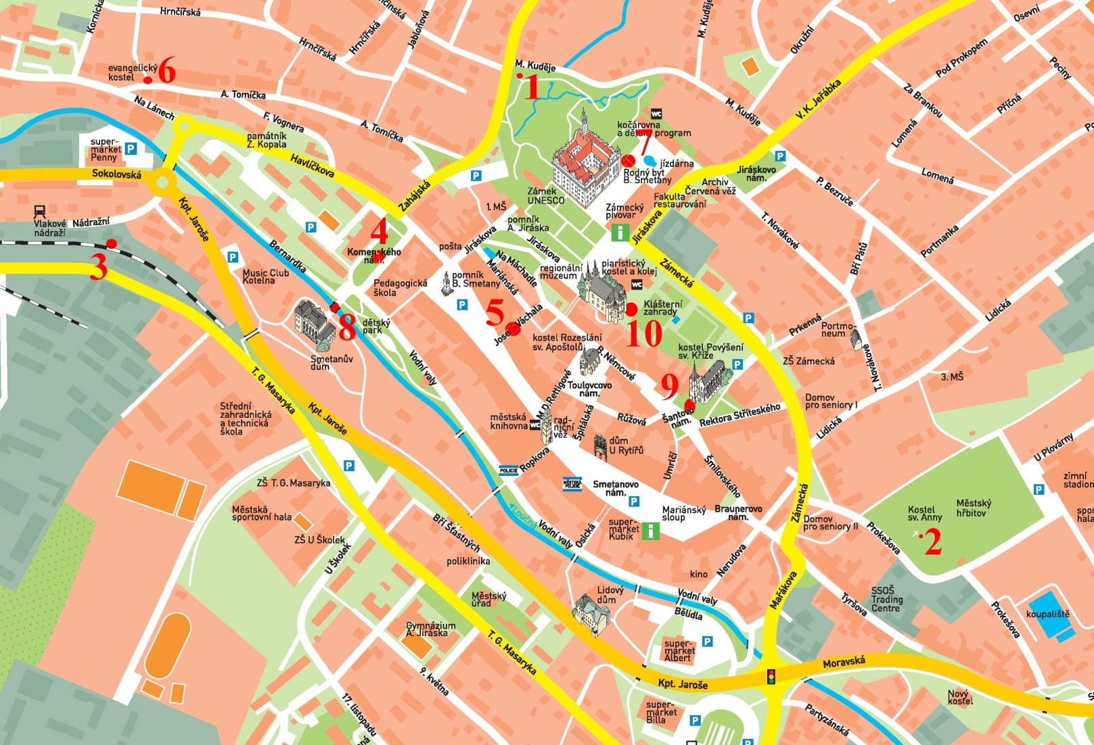**venkovní hra pro každého**

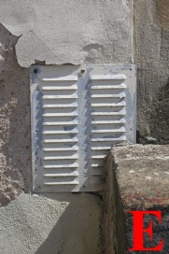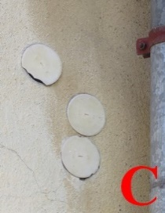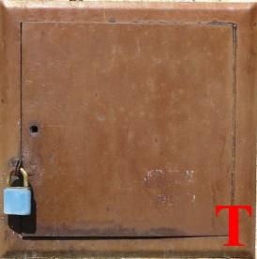

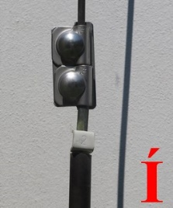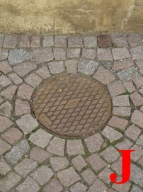

|  |  |  |  |  |  |  |  |  |  |
| --- | --- | --- | --- | --- | --- | --- | --- | --- | --- |
| 1 | 2 | 3 | 4 | 5 | 6 | 7 | 8 | 9 | 10 |
|  |  |  |  |  |  |  |  |  |  |

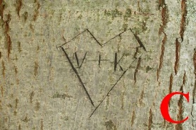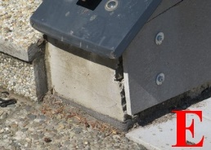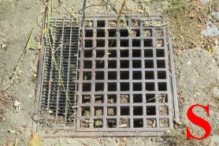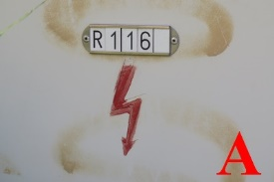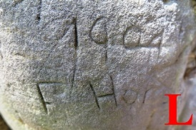

© Hana Klimešová, Regionální muzeum v Litomyšli 2021

© Mapa: Město Litomyšl